An Increasing American Presence: 1849-1852

Pima-Maricopa Irrigation Project Education Initiative
2005-2006

Restoring water to ensure the
continuity of the Akimel O’otham
and Pee Posh tradition of agriculture

Re

The arrival of 40,000 California forty-niners passing through the Pima and Maricopa villages was the beginning of a larger American presence in the Southwest and in what would soon become Arizona Territory. The Treaty of Guadalupe Hidalgo ended the Mexican War, in 1848, and led to the acquisition by the United States of California and New Mexico territory. These territories included the land west of the Rio Grande all the way to the Pacific Ocean and north of the Gila River.
Part 61

Since the Pima and Maricopa villages were largely on the south bank of the Gila they were still part of Mexico when the war ended. But while the villages were in Mexico, they were developing strong economic ties to the United States, if only because of the large number of Americans passing through the villages enroute to California. Within a few years, the Southern and Gila trails had become major transportation routes and stimulated agricultural production in the villages. They had also brought increased American influences, including administrative controls.
By 1850, the Maricopa were living west of Pima Butte scattered along the south bank of the Gila River down to its confluence with the Salt River. The Pima lived to the east of the butte, although there was no clear “dividing line between them.” Described as one large “Indian city,” the Pima and Maricopa villages were “thickly settled” along the river, with the people farming some of the finest fields the Americans had ever seen. Combined, the Pima and Maricopa cultivated perhaps 12,500 acres of land.
While the arrival of the Americans brought new trade goods and increased agricultural production among the Pima and Maricopa, it also significantly influenced the health and well-being of the people. An epidemic of cholera, for instance, broke out in St. Louis, Missouri, in the spring of 1849, spreading to other cities and killing thousands of people. With many forty-niners passing through St. Louis—an important center of trade along the Mississippi River—those arriving at the Pima and Maricopa villages from the east and the south (Gila and Southern trails) brought cholera with them. By the spring of 1851, the deadly disease arrived in Tucson.
None of the journals of the forty-niners mentions any outbreak of disease among the Pima and Maricopa. To suggest deadly contagious diseases were absent, however, would not be accurate. Three Pima calendar sticks describe “black vomiting,” a reference to cholera. Blackwater elder Juan Thomas, for example, transcribed a calendar stick for Charles Southworth in 1914 noting, “Black vomiting, a certain sickness which prevailed through all the settlements, killed the Indians by the hundreds.” The calendar sticks of Mejoe Jackson and John Hayes record the epidemic occurred in the summer of 1850. The disease was not limited to the Pima, as Maricopa interpreter Francisco told John Bartlett in July 1852 that “cholera appeared among them” two years earlier, at the same time Jackson and Hayes remembered the pestilence.
The arrival of the Americans brought additional changes, including the introduction of thousands of cattle, oxen and sheep. As early as 1849, Texas cattlemen began driving herds to new markets in California. Cattle purchased for a few dollars in Texas could bring $300 to $500 in some parts of California, although by 1854 prices leveled off at between $6 and $7 per head. Cowpuncher James Bell recorded in his journal that the Pima grew corn, beans and watermelons of good quality. Bell also observed the “Pemos can muster about two thousand warriors, of as fine looking men as any southern tribe.”
Cattle were not the only herds driven west. Sheep were also driven to California in large numbers. In July 1852, Bartlett met a Mr. Coons in Tucson with 14,000 sheep enroute west. Coons would pass through the Pima villages just days later. The following year, Francois Xavier Aubrey and Francisco Perea drove 50,000 sheep overland to California via the Pima villages.
The main trails by which cattle and sheep were driven west were the Southern and Gila trails, both of which passed through the Pima villages. In 1846, the Pima and Maricopa had few cattle and oxen and no sheep. Within a few years, however, the number of cattle, sheep and oxen in the villages increased, in part from lost or stray animals as well as those traded away by emigrants and trail bosses to the Pima and Maricopa. One trail driver estimated 3,000 head of cattle had been lost along the trails south of the Gila River. Bell reported, “The Indians are in possession” of three-fourths of them. The estimated loss to cattlemen was $75,000, not including “mules, horses and other property.”
At the same time, the Pima and Maricopa tended to their fields as they had done for centuries. Each family cultivated fields “scarcely 150 feet each way” with canals running “around half a dozen fields, giving off branches to each.” Individual fields were approximately one-half acre in size, although it was common for a man to cultivate more than one field. Growing corn, pumpkins, melons, squash, cotton and beans in sufficient amounts to provide for their families, Pima and Maricopa farmers also provided for passersby who came through their villages.
The Pima and Maricopa incorporated a number of changes in their agricultural methods by 1850, most notably adopting the Mexican technique of farming with check beds. Farming with check beds required water from the river entering a lateral that then irrigated small one acre or less plots of land by winding through a series of horizontal rows connected to the next row on the down flow end. Fields were not terraced and consequently required drainage ditches to drain off excess water. In 1855, American geologist Thomas Antisell noted this drainage, although overall he criticized Pima and Maricopa agriculture believing, “More care and economy in the use of water would be necessary” if they were to increase their cultivation. What the geologist meant was Pima farmers, having full use of Gila River water, applied large amounts of water to the land in order to flush out the salts. Without such flushing, salt buildups would not only form a crust on the soil but would also prove harmful to the plants and reduce yields.
Between 1846 and 1852, the Gila and Southern trails became major thoroughfares for the tens of thousands of Americans passing through the Pima and Maricopa villages. More emigrants were aware of the friendship and hospitality of the Pima and Maricopa and they continued to be “treated with marked politeness by members of both tribes.” During the 1850s more travelers would come, and with them came an increased American administrative presence. By the end of the decade some would come to stay, permanently settling and trading with the Pima and Maricopa.

An Increased American Presence

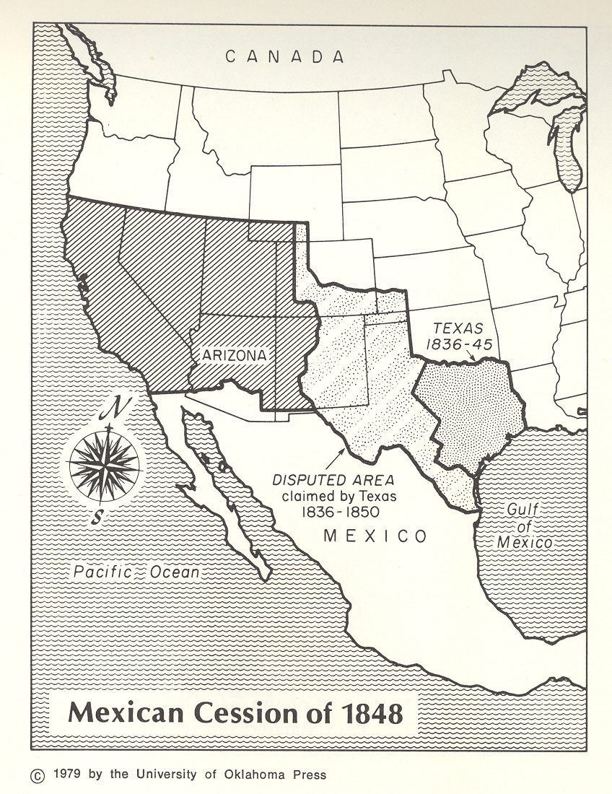
Teacher Plan for “An Increased American Presence”
Objectives

Students will be able to:

- Identify the pros and cons of the American arrival in the 1840s and 1850s.

- Read and draw conclusions from the Treaty of Guadalupe Hidalgo and apply these conclusions to the present day.
Terms to know and understand

- Acquisition
- Administrative
- Ambassador
- Calendar stick
- Epidemic

Critical Thinking:

- Read the Treaty of Guadalupe Hidalgo and identify rights Native Americans (legally classified as Mexican citizens under the Mexican constitution) retained under the treaty. What might this mean today, more than 150 years later? The treaty can be found online at www.loc.gov/exhibits/ghtreaty/.
Activities:

- Using the map on page 3, identify the lands that were part of the Treaty of Guadalupe Hidalgo. Then identify where the Pima and Maricopa villages were located. If the boundary had remained the Gila River, how might the Pima and Maricopa people have been affected? When the boundary was moved to its present location in 1855, the Tohono O’odham were divided. How has this affected their villages?
- Under the Treaty of Guadalupe Hidalgo, the Pima and Maricopa were guaranteed their rights as Mexican citizens but had little recourse in the American system of justice to protect these rights. Under the Gila River Water Settlement Act of 2004, the Community has rights to 653,500 acre-feet of water. To protect this water, have your students write a Water Bill of Rights. This can be modeled on the US Bill of Rights and should include clear statements of the Community’s rights to the water. For example, one provision might be the right of the Pima and Maricopa to learn and practice their cultural traditions relating to water. The protection of good, clear water or the means for handling water disputes in a manner culturally unique to the Pima and Maricopa might be other examples.

About P-MIP

The Pima-Maricopa Irrigation Project is authorized by the Gila River Indian Community to construct all irrigation systems for the Community. When fully completed, P-MIP will provide irrigation for up to 146,330 acres of farmland. P-MIP is dedicated to three long-range goals:
- Restoring water to the Akimel O’otham and Pee Posh.
- Putting Akimel O’otham and Pee Posh rights to the use of water to beneficial use.
- Demonstrating and exercising sound management to ensure continuity of the Community’s traditional economy of agriculture.

